Table of Contents
1. Installation 2
2. Configuration 2
3. Export 3
4. First Steps 4
4.1 First data export 4
4.2 Recommendations 5
4.3 Search 9
5. Integration with custom template 10

1. Installation
- Download and unzip the archive .rar file from the boxalino cloud download section.
- Go to the directory you have just unzipped the plugin into.
- Copy all files and directories into root Shopware directory.
- In your administration backend install the boxalino plugin (Configuration > Plugin Manager > Community extensions). A configuration will appear in the place where you can insert your private and public keys and modify other information. The plugin will not work until you save the settings. Later the configuration will be available under Configuration > Basic Settings > Additional Settings > boxalino.
- You have to configure your Shopware (instruction for each field is in chapter 2. Configuration).
- If anything is changed in the boxalino plugin or boxalino's administration panel, you need clear the cache (http://wiki.shopware.de/Cache_detail_855.html#Clear_cache_from_the_menu).
- By default a daily export is scheduled.

2. Configuration
The configuration is available in Configuration -> Plugin Manager -> Local extensions -> Boxalino after clicking on “Edit plugin” button in Shopware admin panel.

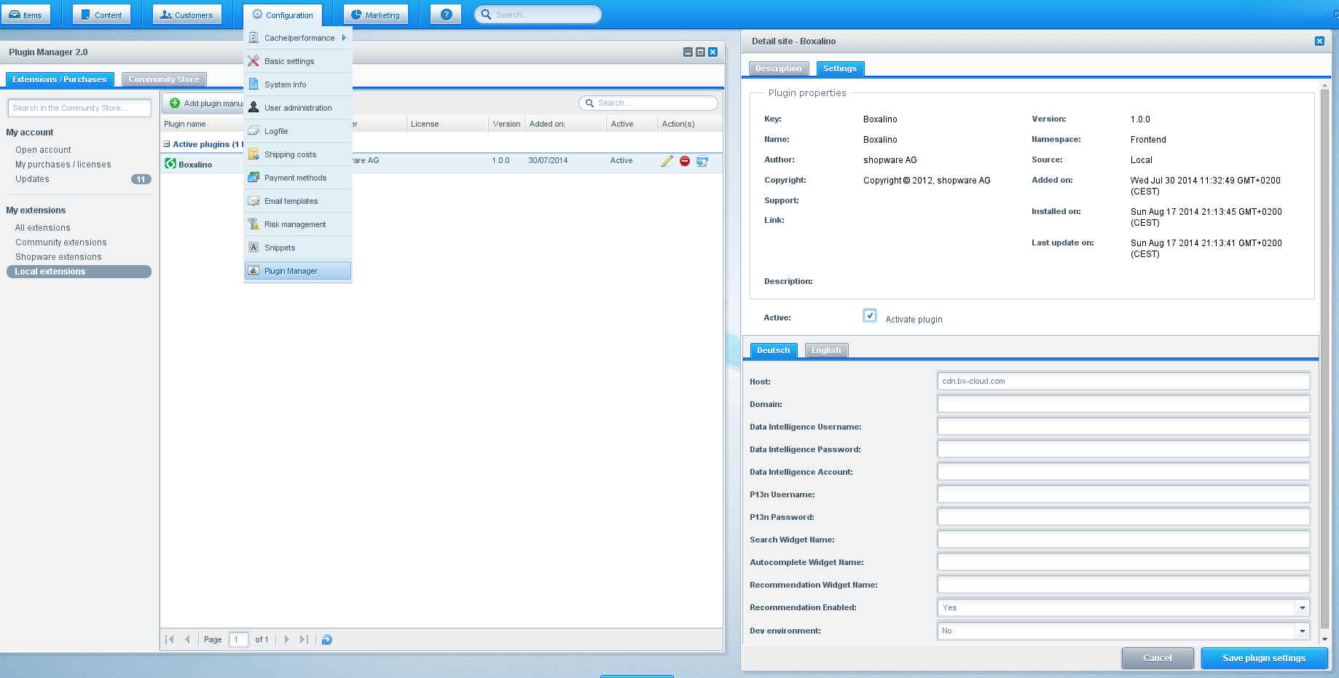
Boxalino Shopware Plugin configuration panel

Some fields have default values. After any change in the configuration you have to refresh your Shopware cache.

- Host - URL to Boxalino Server
- Domain - Actual shop domain
- Data Intelligence Username - Username of the Data Intelligence account
- Data Intelligence Password - Password of the Data Intelligence account
- Data Intelligence Account - Account of the Data Intelligence account
- P13n Username - Username to access API
- P13n Password - Password to access API
- Search Widget Name - Name of widget from Boxalino Data Intelligence used for Search
- Autocomplete Widget Name - Name of widget from Boxalino Data Intelligence used for Autocomplete Search
- Recommendation Widget Name - Name of widget from Boxalino Data Intelligence used for Recommendation
- Recommendation Enabled – Recommendation widget status
- Dev environment - If true, then development account is used

3. Export
Navigate to Content -> Import / export -> Boxalino Export.

Choose either Full export or Delta export. (Full export exports all data to the server. Delta export exports only data modified later then last export was made).

Exporting can take some time. Please wait for a popup window with results. Some browsers may try to block it from appearing.

After the export you may be required to take some actions in the boxalino's administration panel.

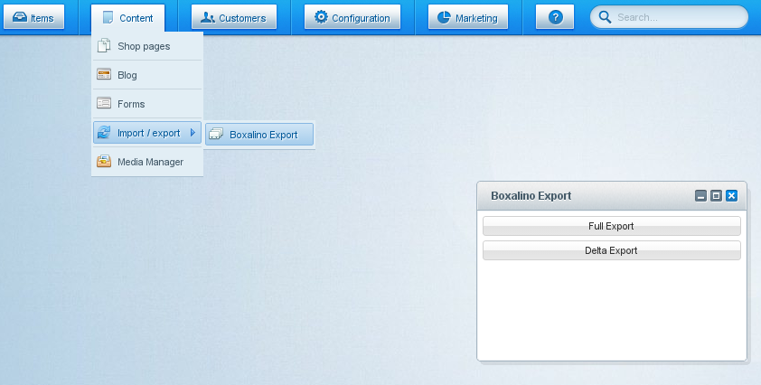
Boxalino Shopware Plugin Export

4. First Steps

When your Shopware configuration will be done, then you can start with preparing your Data Intelligence account to work with your shop. As there is no data before the first reindex, the following problems may occure.

4.1 First data export
Firstly, you can meet a problem like:
“Server at http://localhost:7575/solr returned non ok status:404, message:Not Found”
In this case, please follow instructions bellow:

- Go to option: Content -> Import / export -> Boxalino Export. in your Shopware Admin Panel and click on Full export.

After first reindex you can meet an error:
“CEMException: Try to publish without should publish = true”
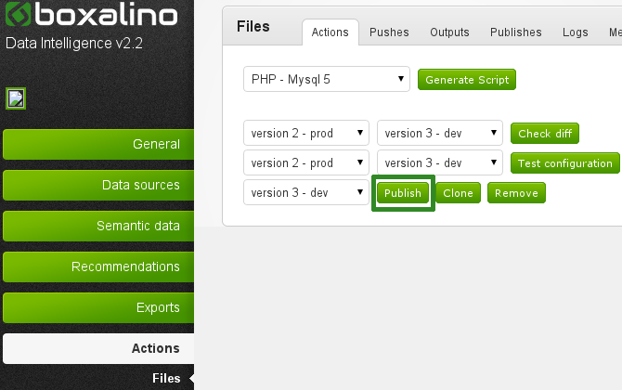
- In the next step you must log in here: http://di1.bx-cloud.com/frontend/dbmind/en/dbmind/login (using your Data Intelligence credentials). Next go to options Actions->Files and in tab “Actions” click button “Publish”.

Configuration versioning in the Boxalino Data Intelligence

- Then you can back to your Shopware Admin Panel and execute reindex for Full export again.

4.2 Recommendations

If you have enabled recommendation, then you can meet an error on your product or basket page:
“choice not found: widget_name”
Where “widget_name” can be name from “Widget name” from settings System->Configuration->Boxalino Recommendation

In this case, please follow instructions bellow:
- You login here: http://di1.bx-cloud.com/frontend/dbmind/en/dbmind/login (using your Data Intelligence credentials)
- Go to option: Recommendations->Widgets and then click button “Add a new element”, fill input below “Name:” and click button “Add”
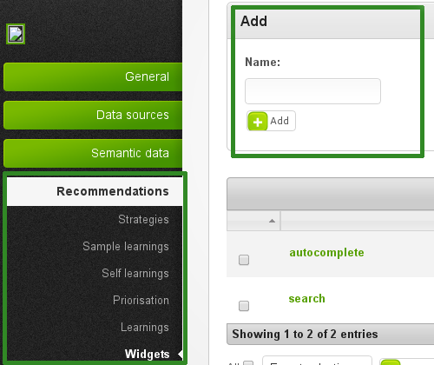
Boxalino Data Intelligence – creating new widget
- Using names from Widget Name option from your Shopware Admin Panel is the best way. Fill input below Widget Name on next page (similar like text below “ID” on current page). In drop-down below “type” you can choose type of widget (we recommend “basket – x-sell” for basket recommendation and “product – similar” for product recommendation) . After that, click button “Update”.
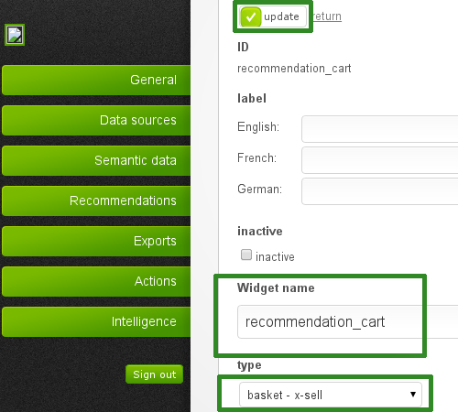
Boxalino Data Intelligence – widget configuration

- In next step, go to Recommendations->Strategies (new) where you can create a new strategy for widget. Please fill input below “Name:” and click button “Add”.

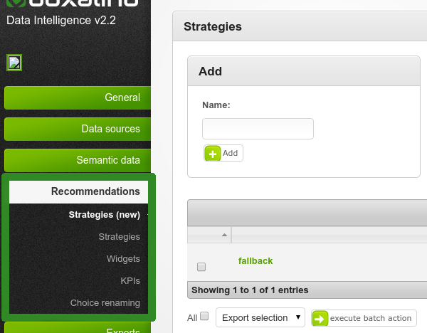

Boxalino Data Intelligence – creating new strategy
- On next page you can configure how your strategy should work.
- Tab “General”
  - Widgets - You can choose which widget should use the strategy
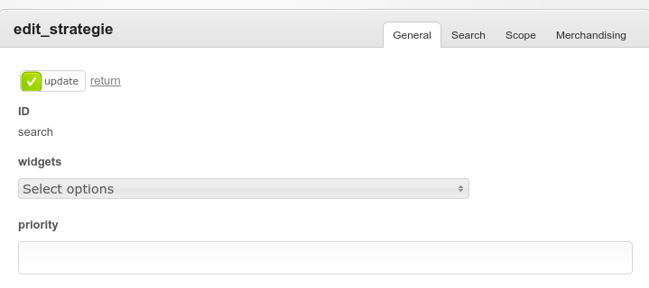
Boxalino Data Intelligence – strategy configuration
- Tab “Search”
  - search_parameter - Name of search parameter
  - search_scope – Parameter how results should be calculated
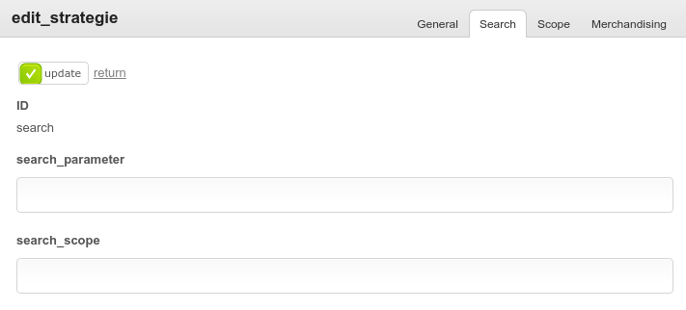
Boxalino Data Intelligence – strategy configuration
- Tab “Scope”
  - target_conditions – You can add conditions to filter products (you can create conditions in Semantic data->Conditions)
  - optimization_criteria – You can choose how recommendation should be optimized
  - item_2_item_criteria - You can choose which field should be used for item_2_item logic
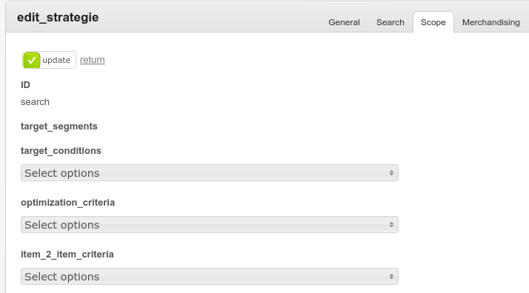
Boxalino Data Intelligence – strategy configuration

- Tab “Merchandising”
  - ranking – You can choose which field should be used as ranking
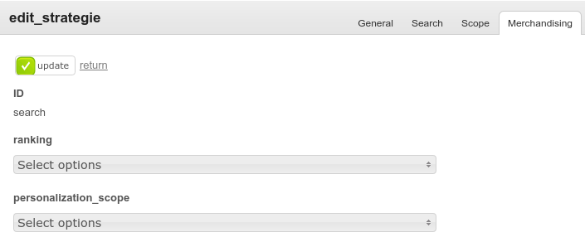
Boxalino Data Intelligence – strategy configuration
- After full configuration of your strategy, you can click button “Update” in down-right corner.

Step 7 and 8 are additional and you do not need to perform them.
- If you want, you can create more than 1 strategy for widget. Furthermore, you can add strategy as fall-back (fall-back strategy is used when no product is found for other strategies, then fall-back strategy should be general)
- If you want to add your strategy as fall-back:
- Don't connect this strategy with your widget in Recommendations->Strategies (new)
- Back to Recommendations->Widgets, click “edit” on widget which you want to have fall-back
- In drop-down below “fall_back_strategy” you can choose which strategy should be used as fall-back and click button “Update”
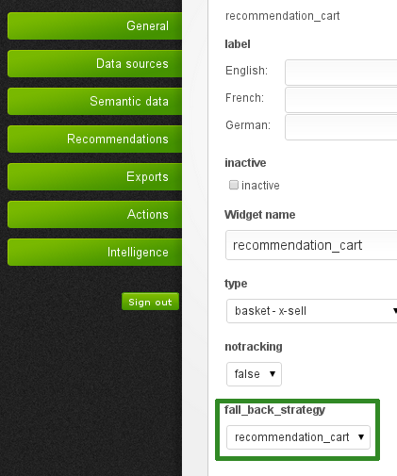
Boxalino Data Intelligence – widget configuration

- When you have created widgets and strategies, then you can execute task “generate_optimization”. To do that, go to Actions->Task processes, click “edit” button near “generate_optimization” task. At the first time on next page you must fill input near “customer” with your Data Intelligence Username. Now click button “update”. Then click button “execute task”.
- Sometimes you must wait about 5 minutes before cache reloads.

4.3 Search
Similarly to recommendation, when you try to search something, you can meet the following problems:
“choice not found: search” or “choice not found: autocomplete”
In this case, you must create two new strategies: one named “search” - connected with widget “search” and the other “autocomplete” - connected with widget “autocomplete”.
In tab “Search” in first input near “Search parameter:” you must add the value “searchQuery” and in the other input you must add “title:10,body:1,scorerTerms:2”.
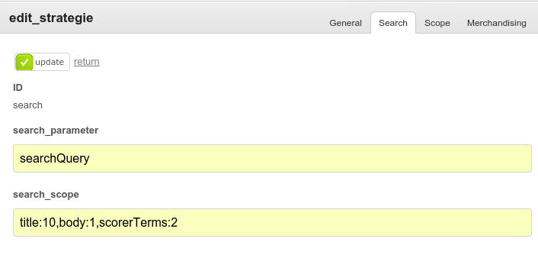
Boxalino Data Intelligence – strategy configuration

When you create both strategies, you must execute “generate_optimization” task again.

5. Integration with custom template

Our Boxalino Shopware Plugin is rewriting core methods of Shopware. In this case everything is
using default functionalities of Shopware. You don't need to change anything, just install plugin.
Furthermore you can disable recommendation on products page by change configuration in
Shopware Admin Panel.

